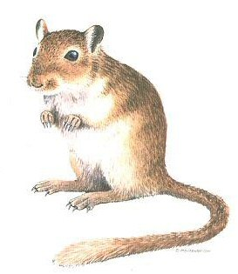**Assessment**

1. Joshua wants to study his pet gerbil, Gizmo, for his science fair project. His uncle is helping him build a cage for Gizmo.

* 1. What tool should Joshua use to measure the length of the cage?

*___________________*

* 1. What metric unit should he use to record the length? *_________________*
  2. What measuring tool should he use to measure the volume of water Gizmo drinks each day? *______________________________________*
  3. What metric unit should he use to record the volume of the water? *___________*
  4. What measuring tool should he use to measure the mass of food Gizmo eats each day? *_______________________________________*
  5. What metric unit should he use to record the mass of the food? *_____________*
  6. Joshua needs to measure the temperature of Gizmo’s environment to make sure it is not too hot and not too cold. What measuring tool should he use to do this?

*______________________________*

* 1. What metric unit should he use to record the temperature? *________________*

2. Juan and Kym have four samples of matter. They are observing and describing the properties of these samples. Which property will best provide evidence that the samples are solids rather than liquids?

a. Mass

b. Color

c. Length

d. Shape

3. Name two examples of a **mixture.** Explain how you know these are mixtures.

__________________________________________________________________________________________________________________________________________________________________________________________________________________________________________________________________________________________________________________________________________________________________________________________________________________

4. Raheem is investigating the properties of several substances. He prepared a beaker containing substances J, K, and L and filtered the contents through a funnel into a flask, as shown below.

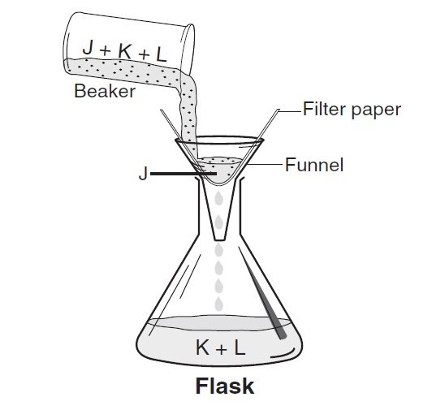

What term best describes substances J, K, and L inside the beaker before Raheem poured them through the filter paper?

1. Mixture
2. Solid
3. Compound
4. Liquid
5. Which of the following is NOT matter?

Milk

Cotton candy

Music

Air

Explain your reasoning.

______________________________________________________________________________________________________________________________________

1. Henry is measuring the mass of four different blocks with letters on them. Look at

the pictures below.

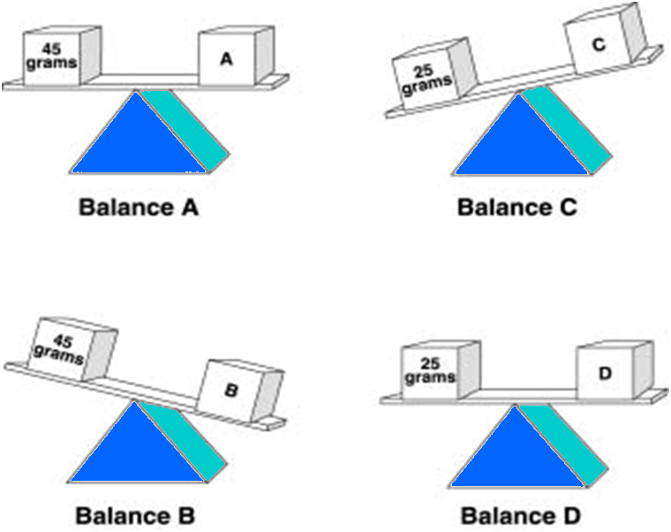

Which block has the greatest mass?

* + - * 1. Block A
        2. Block B
        3. Block C
        4. Block D

7. A student added a small ball to a graduated cylinder containing 10 milliliters of water.



What is the volume of the ball?

* + - * 1. 5 ml
        2. 10 ml
        3. 15 ml
        4. 20 ml

8. A student pushed a toy car from Point W to Point X in 3 seconds.

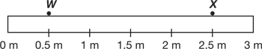

Which statement best describes the distance the car traveled?

1. The car traveled 2 meters.
2. The car traveled 2.5 meters.
3. The car traveled for 3 seconds.
4. The car traveled 3 meters per second.