**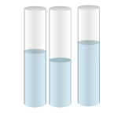Big Idea 8 Properties of Matter**

**Florida Next Generation Sunshine State Standards:**

**SC.5.P.8.1** – Compare and contrast the basic properties of solids, liquids, and gases, such as mass, volume, color, texture, and temperature.

**SC.5.P.8.3** –Demonstrate and explain that mixtures of solids can be separated based on observable properties of their parts such as particle size, shape, color, and magnetic attraction.

## Terms

|  |  |  |
| --- | --- | --- |
| **English** | **Spanish** | **Haitian Creole** |
| 1. accurate | preciso | egzat |
| 1. balance | balanza/báscula | balans |
| 1. Celsius | Centígrado | Santigrad |
| 1. centimeter | centímetro | santimèt |
| 1. Fahrenheit | Fahrenheit | Farennhayt |
| 1. gas | gas | gaz |
| 1. graduated cylinder | cilindro graduado/probeta | silend kalibre |
| 1. gram | gramo | gram |
| 1. gravity | gravedad | pezantè/gravite |
| 1. inch | pulgada | pous |
| 1. length | largo | longè |
| 1. liquid | líquido | likid |
| 1. liter | litro | lit |
| 1. mass | masa | mas |
| 1. matter | material | matyè |
| 1. measure | medida | mezire |
| 1. meniscus | menisco | menisk |
| 1. meter | metro | mèt |
| 1. milliliter | mililitro | mililit |
| 1. mixture | mezcla | melanj |
| 1. ruler | regla | règ |
| 1. spring scale | balanza de muelles | balans |
| 1. solid | sólido | solid |
| 1. states of matter | estados de la materia | eta matyè yo |
| 1. temperature | temperatura | tanperati |
| 1. thermometer | termómetro | tèmomèt |
| 1. volume | volumen | volim |
| 1. weight | peso | pwa |

**Does This Matter to Me?**

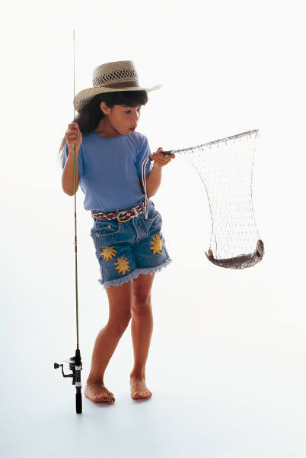Matter is all around you, so properties of matter should matter to you. You could get by in life using words like heavy and light, hot and cold, long and short, even though these words mean different things to different people. However, in science, to study matter and its properties, we describe observations with measurements. Using observations and measurements, the experiment or model can be repeated the same way the next time. Knowing about measurement and properties of matter can help you in areas besides science, such as to be a good cook, to make a recipe the right way every time, or to fix cars or motorcycles. Even fun activities like fishing and shopping require you to take measurements and compare them carefully. Let’s learn about properties of matter so that you have skills that will help you to do these activities and more.

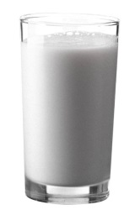

Every day you interact with matter in solid, liquid, and gas forms. Fill in the table with different types of matter you have observed since you woke up this morning. Where did you observe this matter? What sense did you use to observe it? Was it a solid, liquid or gas? What properties do you remember, such as color, texture (hard, soft, squishy), shape, etc.?

|  |  |  |  |  |
| --- | --- | --- | --- | --- |
| Matter | Place | Sense(s) Used | Solid,  Liquid, or Gas? | Properties  (color, texture, shape, etc.) |
| *Example: milk* | ***at home*** | ***sight, touch*** | ***liquid*** | ***white, opaque, in glass, cool*** |
|  |  |  |  |  |
|  |  |  |  |  |
|  |  |  |  |  |
|  |  |  |  |  |
|  |  |  |  |  |

**Describing and Comparing Basic Properties of Matter**

**(SC.5.P.8.1)**

All objects and substances are **matter**. Matter takes up space and has **mass**. Matter can also take three different forms or states: **solid**, **liquid**, and **gas**. Matter has basic properties, such as mass, volume, color, texture, and temperature. Each of these properties can be observed, described, **measured**, and recorded. Describing the properties of matter allows you to compare and contrast different types of matter.

Just as we use various tools to measure things at home, we use various tools to measure when we are doing scientific investigations. The following table lists some examples of measurement. What types of measurements have you made at home? What types of measurements have you made at school?

|  |  |  |  |
| --- | --- | --- | --- |
| **Properties...** | **Tools…** | **At home…** | **At school…** |
| **Length**  **(Height)** | http://www.eaieducation.com/images/products/531112_M.jpg | …we use a yard stick or a meter stick to measure our height, fabric for sewing clothes, or wood before cutting and building | …we use similar tools (e.g., rulers, meter sticks, tape measures) to measure distance |
| **Volume** | [http://ts1.mm.bing.net/th?id=H.4703191963730788&pid=1.7&w=184&h=151&c=7&rs=1](http://www.bing.com/images/search?q=teaspoon&qs=n&form=QBIR&pq=teaspoon&sc=8-8&sp=-1&sk=#view=detail&id=52D5D959996844253F2E965276C95232273C9F7A&selectedIndex=65) | …we use teaspoons and tablespoons to measure volumes of wet and dry ingredients when cooking | …we use graduated cylinders and beakers to measure volume |
| **Temperature** | http://www.rainiervalleypost.com/wp-content/uploads/2009/05/thermometer.jpg | …we use indoor/outdoor thermometers to measure air temperature, and digital thermometers to check for a fever | …we use laboratory grade thermometers to measure temperature |

Throughout the entire world, people measure using the metric system whether they are at home or at school in the science lab. The metric system uses units like the **meter**, **gram, liter**, anddegrees **Celsius (°C)**. The United States is one of only three countries in the world where most people use the older customary system on a daily basis like the yard, gallon, and ounce. Only some people in the U.S. use the metric system for science-related work such as engineers, medical doctors, nurses, biologists, geologists, etc.

**Length**

You will measure the **lengths** of objects using the customary **inch** (in) and the metric **centimeter** (cm). The units for measuring length in the customary system are inches, feet, and yards. There are 12 inches in one foot, and 3 feet in one yard. In the metric system, the standard unit of length is the meter (m). There are 100 centimeters in a meter. Each centimeter is divided into 10 parts called millimeters (mm). Measure the lengths to the nearest ¼ inch (in), 0.1 centimeter (cm), or 1 millimeter (mm). An inch is divided into 16 parts, and a centimeter is divided into 10 parts. Which unit of measurement do you think would be easier to use in science? Explain your reasoning.

\_\_\_\_\_\_\_\_\_\_\_\_\_\_\_\_\_\_\_\_\_\_\_\_\_\_\_\_\_\_\_\_\_\_\_\_\_\_\_\_\_\_\_\_\_\_\_\_\_\_\_\_\_\_\_\_\_\_\_\_\_\_\_\_\_\_\_\_\_\_

\_\_\_\_\_\_\_\_\_\_\_\_\_\_\_\_\_\_\_\_\_\_\_\_\_\_\_\_\_\_\_\_\_\_\_\_\_\_\_\_\_\_\_\_\_\_\_\_\_\_\_\_\_\_\_\_\_\_\_\_\_\_\_\_\_\_\_\_\_\_

To measure the length of an object, we use a **ruler** or meter stick. These instruments are best for measuring straight lines and surfaces. For example, you could measure the edge of a piece of paper with a ruler, or the length of a wall with a meter stick. If you were trying to measure the length of a piece of string, you would need to straighten it before measuring it. Be sure to line up the “0” marked on your ruler with the end of the object you are measuring.

**Length Activity: How Can You Measure the Lengths of Objects?**

Materials (per small group):

* 1 ruler or meter stick that measures in both metric (cm) and customary (in) units

Procedures: Look at the objects listed in the table below. Follow the steps.

1. Estimate the length of the first object (textbook) in inches (in) and centimeters (cm).

2. Record the estimated length of the textbook in inches and centimeters.

3. Using the ruler or meter stick, measure and record the actual length of the textbook in inches and centimeters.

4. Repeat steps 1-3 for the remaining objects.

|  |  |  |  |  |
| --- | --- | --- | --- | --- |
| **Object** | **Estimated length** | | **Actual length** | |
| **inch**  **(in)** | **centimeter**  **(cm)** | **inch**  **(in)** | **centimeter**  **(cm)** |
| Length of textbook |  |  |  |  |
| Length of desk top |  |  |  |  |
| Length of student’s little finger |  |  |  |  |
| Distance (length) from student’s wrist to elbow |  |  |  |  |
| Distance (length) from student’s elbow to shoulder |  |  |  |  |

**Mass**

**Mass** is the amount of matter in an object. To find the mass of an object you would use a **balance** like the one shown here.

A balance compares two objects. Notice there are no numbers on this instrument. There is a little arrow between the two pans. The balance shows whether one side is heavier than the other. If the masses on both sides are equal, the arrow sits in the middle and we could say, “The two sides are in balance.” To find the mass of an object, we use standard masses in one of the pans of the balance. The plastic pieces in the picture are standard masses.

The unit of mass in the metric system is a gram (g). Grams can be divided into 1,000 parts called milligrams (mg). For the following activity, you will be using the unit gram to measure mass (for example, 15 g).

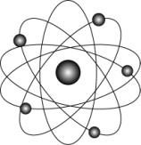

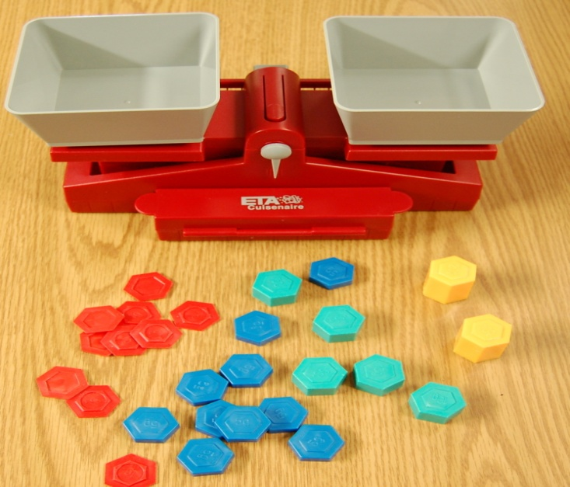

**Mass Activity: How Can You Measure the Masses of Objects?**

You will measure the masses of four objects to the nearest gram. You may have to make several attempts using different combinations of standard masses to find a state of balance.

Materials (per small group):

* 1 balance
* 1 set of standard masses

Procedures: Choose four small objects to measure. Follow the steps below.

1. Estimate the mass of the first object in grams (g).

2. Record the estimated mass of the first object in grams.

3. To calibrate the scale, make sure that the balance indicator is initially set at the midpoint line without any weights or objects on the pans.

4. Measure the mass of the first object in grams.

5. Record the actual mass of the first object in grams.

6. Repeat steps 1-5 for each object.

|  |  |  |
| --- | --- | --- |
| **Object** | **Estimated mass** | **Actual mass** |
| **grams (g)** | **grams (g)** |
| a. |  |  |
| b. |  |  |
| c. |  |  |
| d. |  |  |

**Volume**

**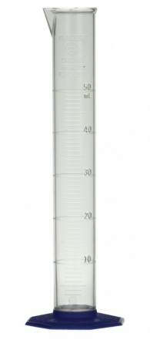**

**Volume** is one physical property of matter. It is a measure of how much space an object takes up.

A **graduated cylinder** is a tool that is used to measure the volume of a liquid. The unit for measuring the volume of a liquid in the metric system is the **liter** (L). The liter is divided into 1,000 parts or **milliliters** (ml). To obtain **accurate** measurements, it is important that you place the graduated cylinder on a flat surface. It is also important to observe the liquid at eye level and read the marking at the bottom of the curve. This curve is called the **meniscus**.

Look at the model of a section of a graduated cylinder.

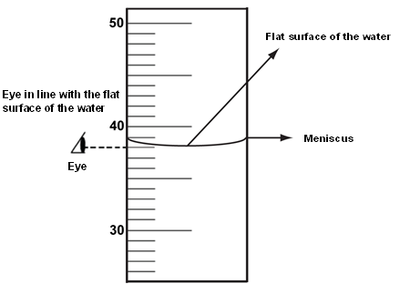

What is the volume of the liquid in the graduated cylinder? This liquid’s volume is 38 milliliters (ml). We can measure volume of liquids with tools like a graduated cylinder because liquids retain their volume regardless of the shape of the container. A box of juice has the same volume when you pour it into your glass.

**Volume Activity: How Can You Measure the Volume of Solids?**

Find the volume of two balls using the water displacement method.

Materials (per small group):

* 1 graduated cylinder
* water
* 2 balls (same type)

Procedures:

1. Add 100 ml of water to a 250 ml graduated cylinder. Record this amount in the table.
2. Add 2 balls to the cylinder and measure the new volume of water. Record this amount in the table.
3. Find the difference between the two measurements and record in the table.
4. The difference between the two measurements will be the volume of the two balls.

|  |  |  |  |
| --- | --- | --- | --- |
| **Volume of Water Before Adding Two Balls** | **Volume of Water After Adding Two Balls** | **Difference in Volume** | **Volume of Two Balls** |
|  |  |  |  |

Based on the volume of the two balls, can you predict the volume of one ball? Explain your reasoning.

\_\_\_\_\_\_\_\_\_\_\_\_\_\_\_\_\_\_\_\_\_\_\_\_\_\_\_\_\_\_\_\_\_\_\_\_\_\_\_\_\_\_\_\_\_\_\_\_\_\_\_\_\_\_\_\_\_\_\_\_\_\_\_\_

\_\_\_\_\_\_\_\_\_\_\_\_\_\_\_\_\_\_\_\_\_\_\_\_\_\_\_\_\_\_\_\_\_\_\_\_\_\_\_\_\_\_\_\_\_\_\_\_\_\_\_\_\_\_\_\_\_\_\_\_\_\_\_\_

\_\_\_\_\_\_\_\_\_\_\_\_\_\_\_\_\_\_\_\_\_\_\_\_\_\_\_\_\_\_\_\_\_\_\_\_\_\_\_\_\_\_\_\_\_\_\_\_\_\_\_\_\_\_\_\_\_\_\_\_\_\_\_\_

\_\_\_\_\_\_\_\_\_\_\_\_\_\_\_\_\_\_\_\_\_\_\_\_\_\_\_\_\_\_\_\_\_\_\_\_\_\_\_\_\_\_\_\_\_\_\_\_\_\_\_\_\_\_\_\_\_\_\_\_\_\_\_\_

The volume of a regular solid can be calculated using a ruler. For example, using a ruler, the volume of a rectangular object can be measured by calculating length x width x height. The volume of an irregular solid (for example, an eraser or a toy car) can be calculated using the water displacement method you just used to measure the volume of two balls.

**Temperature**

Let’s think about the weather.

Is it hot outside today? \_\_\_\_\_\_\_\_\_\_\_\_\_\_\_\_\_\_\_\_\_\_\_\_\_\_\_\_\_\_\_\_\_\_\_\_\_\_\_\_\_\_\_\_\_\_\_\_

Is it usually hotter in winter or summer? \_\_\_\_\_\_\_\_\_\_\_\_\_\_\_\_\_\_\_\_\_\_\_\_\_\_\_\_\_\_\_\_\_\_\_

Is it usually cooler on a cloudy day or a sunny day? \_\_\_\_\_\_\_\_\_\_\_\_\_\_\_\_\_\_\_\_\_\_\_\_\_

Where are the coldest places on Earth? \_\_\_\_\_\_\_\_\_\_\_\_\_\_\_\_\_\_\_\_\_\_\_\_\_\_\_\_\_\_\_\_\_\_

Where are the hottest places on Earth? \_\_\_\_\_\_\_\_\_\_\_\_\_\_\_\_\_\_\_\_\_\_\_\_\_\_\_\_\_\_\_\_\_\_\_

We use the word **temperature** when we talk about how cold or hot something is. Look at the pictures of the **thermometers**. You will see that each thermometer has two measurement systems. One unit for measuring temperature is called **Fahrenheit (°F)** and the other is called **Celsius (°C).** Fahrenheit is part of the customary system and Celsius is part of the metric system. When reading thermometers like the ones shown, the top of the red liquid indicates the temperature. The left thermometer shows the temperature at which water freezes, 32 °F or 0 °C. Although these are two very different numbers, they represent the same temperature on two different scales. The right thermometer shows the temperature at which water boils, 212 °F or 100 °C. Again, these temperatures are the same, but they are recorded as two very different numbers on two very different scales, Fahrenheit and Celsius.

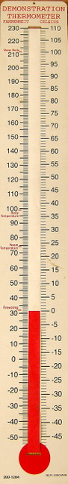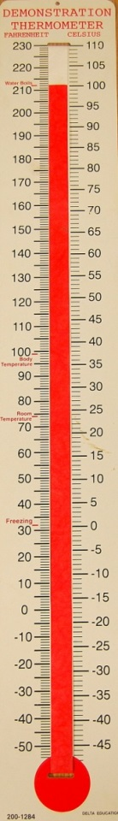

Celsius (°C)

Fahrenheit(°F)

Let’s investigate how the thermometer works. Place your finger gently on the bulb at the bottom of the thermometer for 30 seconds. What happens to the red liquid in the tube?

\_\_\_\_\_\_\_\_\_\_\_\_\_\_\_\_\_\_\_\_\_\_\_\_\_\_\_\_\_\_\_\_\_\_\_\_\_\_\_\_\_\_\_\_\_\_\_\_\_\_\_\_\_\_\_\_\_\_\_\_\_\_\_\_\_\_\_\_\_\_

Now take your finger off the bulb and wait 30 seconds. What happens to the red liquid?

\_\_\_\_\_\_\_\_\_\_\_\_\_\_\_\_\_\_\_\_\_\_\_\_\_\_\_\_\_\_\_\_\_\_\_\_\_\_\_\_\_\_\_\_\_\_\_\_\_\_\_\_\_\_\_\_\_\_\_\_\_\_\_\_\_\_\_\_\_\_

Gently hold the capillary (the long part of the thermometer) in your hand for 30 seconds. What happens to the red liquid in the tube?

\_\_\_\_\_\_\_\_\_\_\_\_\_\_\_\_\_\_\_\_\_\_\_\_\_\_\_\_\_\_\_\_\_\_\_\_\_\_\_\_\_\_\_\_\_\_\_\_\_\_\_\_\_\_\_\_\_\_\_\_\_\_\_\_\_\_\_\_\_\_

As the temperature increases, the liquid rises or goes up in the tube. As the temperature decreases, the liquid in the tube falls or goes down. You can see why it is important to keep your finger off the bulb of the thermometer when you are measuring the temperature of something. When you measure the temperature of various objects, it is important to wait about 2 minutes to allow the thermometer to adjust to its new environment. When the liquid in the bulb of the thermometer is adjusted, the liquid in the capillary stops moving up or down and you can read the temperature. In addition, it is important to read the red line on this type of thermometer at eye level.

Look at the 0-point on the Celsius scale and the 0-point on the Fahrenheit scale on the thermometer. The numbers below the 0 point are called negative numbers. The further below 0 the red liquid gets, the colder the sample is. For example, -30 (minus 30) degrees Celsius is colder than -10 degrees Celsius. Numbers below zero are read, for example, as 10 degrees below 0 or -10 (minus 10) degrees.

**Temperature Activity: How Can You Measure Water Temperature?**

With the members of your group, you will measure the temperature of various water samples and complete the table below.

Materials (per small group):

* 1 cup of cold water
* 1 cup of hot water
* 1 cup of warm water
* 1 thermometer

Procedures:

1. Place the thermometer in the water sample and allow the thermometer to adjust for 2 minutes before you read the thermometer. Using the Celsius and Fahrenheit scales, record the temperature in the Data Table.
2. Repeat step 1 until you have measured every sample.

|  |  |  |
| --- | --- | --- |
| **Item** | **Degrees Celsius** | **Degrees Fahrenheit** |
| a. Cold water | °C | °F |
| b. Hot water | °C | °F |
| c. Warm water | °C | °F |

**Three States of Matter**

**(SC.5.P.8.1)**

**We want to answer the questions:**

*a. What is matter?*

*b. What are the three states of matter? How can you tell one state from another?*

To determine whether an object is matter or not, you need to examine the object by considering two questions. First, does it have mass? Second, does it take up space? **Matter** has mass and takes up space.

Matter exists in three basic states: solid, liquid, and gas. To classify each object as one of three **states of matter,** you need to examine its shape along with its volume. Does it have a definite shape, or does it change its shape? Shape, like volume, is a physical property of matter. Solids have a definite volume and a definite shape. Liquids are fluid; they have a definite volume but not a definite shape and take the shape of the container. Gases have no fixed volume or shape.

**Is It Matter?**

For each of the substances in the table, answer the questions in the first two columns.

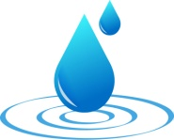 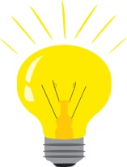 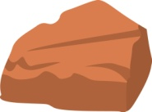 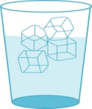 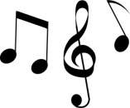 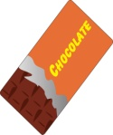 C:\Users\LACFSUPHD\AppData\Local\Microsoft\Windows\Temporary Internet Files\Content.IE5\663KBJOY\MC900021454[1].wmf

Use those answers to decide if the substance is matter or not. For the substances that are matter, decide what state of matter they are at room temperature.

|  |  |  |  |  |
| --- | --- | --- | --- | --- |
| **Substance** | **Does it have mass?**  **Yes or No?** | **Does it take up space?**  **Yes or No?** | **Is it matter?**  **Yes or No?** | **If it is matter, what state is it?**  **(solid, liquid, or gas)** |
| Water |  |  |  |  |
| Light |  |  |  |  |
| Rock |  |  |  |  |
| Ice cubes |  |  |  |  |
| Music |  |  |  |  |
| Chocolate  bar |  |  |  |  |
| Air |  |  |  |  |

**Mixtures**

**(SC.5.P.8.3)**

A **mixture** is made from two or more kinds of matter that are physically blended together.

Some mixtures are made of solid ingredients, and they are called solid mixtures. Breakfast cereal made of flakes, raisins, nuts, and bananas is a solid mixture. A bowl of nuts containing cashews, macadamia nuts, almonds, and pecans is also a solid mixture. In these mixtures, you can easily separate its components by picking them out.

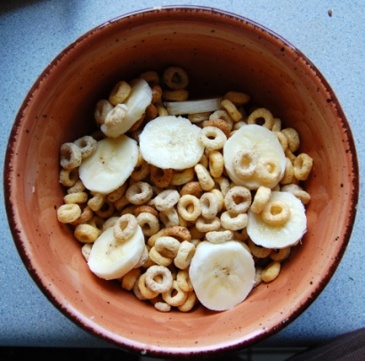 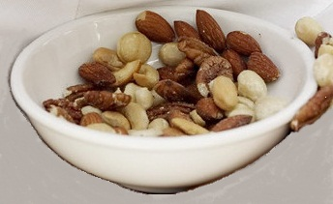

**Breakfast Cereal** **Bowl of Nuts**

Mixtures can be a combination of two or more liquids. For example, if you combine oil and water for a salad dressing, you can see drops of oil suspended in the water as you begin to stir these liquids together. If you shake the mixture vigorously, the oil droplets are made smaller and smaller and the mixture starts to look homogeneous. However, if you leave the mixture undisturbed, the oil and water will separate again.

Mixtures can be a combination of solids and liquids. Chicken noodle and vegetable soups are mixtures of both solid and liquid ingredients. Are you able to separate the vegetables from the broth in a soup?

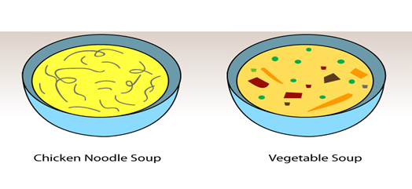

Mixtures can be made of gases. For example, the air in the Earth’s atmosphere is a mixture of nitrogen, hydrogen, oxygen, carbon dioxide, water vapor, and other gases. Are you able to tell the different gases apart with the naked eye?

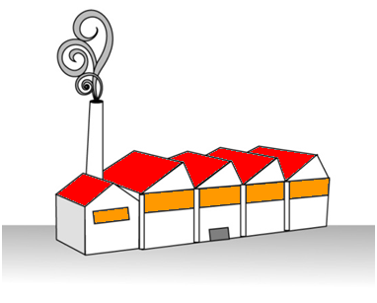

**Gas**

When you physically combine two or more materials, you make a mixture. Mixtures can also be taken apart or separated back into their original ingredients. Substances in a mixture may retain separate physical properties. Physical properties are characteristics of a substance, like size, color, texture, or magnetism.

In Inquiry 2 below, you will start with a mixture of solid materials. Then, you will investigate to determine if you can use the physical properties of the materials to separate the mixture back into its original materials.

**Inquiry 2: Separating Salt, Sand, and Iron Filings**

**(SC.5.P.8.3)**

|  |  |  |
| --- | --- | --- |
| **Inquiry Framework** | | |
| **1. Questioning**  questioning | **State the problem**  *How can you use physical properties (color, size, shape, temperature, magnetism, or state) to separate a mixture of salt, sand, and iron filings?*  **Make a prediction**  Physical properties can be used to separate a mixture of salt, sand, and iron filings.  Physical properties can be used to separate some of the solids in the mixture.  Physical properties cannot be used to separate any of the solids in the mixture. | |
| **2. Planning**  **planning** | **Read the materials and procedures**   * Do I have all of the necessary materials?   Yes  No   * Have I read the procedures?   Yes  No   * Summarize the procedures in your own words.   \_\_\_\_\_\_\_\_\_\_\_\_\_\_\_\_\_\_\_\_\_\_\_\_\_\_\_\_\_\_\_\_\_\_\_\_\_\_\_\_\_\_\_\_\_\_\_\_\_\_\_\_\_\_\_\_\_\_\_\_\_\_\_\_\_\_\_\_\_\_\_\_\_\_\_\_\_\_\_\_\_\_\_\_\_\_\_\_\_\_\_\_\_\_\_\_\_\_\_\_\_\_\_\_\_\_\_\_\_\_\_\_\_\_\_\_\_\_\_\_\_\_\_\_\_\_\_\_\_\_\_\_\_\_\_\_\_\_\_\_\_\_\_\_\_\_\_\_\_\_\_\_\_\_\_\_\_\_\_\_\_\_\_\_\_\_\_\_\_\_\_\_\_\_\_\_\_\_\_\_\_\_\_\_\_\_\_\_\_\_\_\_\_\_\_\_\_\_\_\_\_\_\_\_\_\_\_\_\_\_\_\_\_\_\_\_\_\_\_\_\_\_\_\_\_\_\_\_\_\_\_\_\_\_\_\_\_\_\_\_\_\_\_\_\_\_\_\_\_\_\_\_\_\_\_\_\_\_\_\_\_\_\_\_\_\_\_\_\_\_\_\_\_\_\_\_\_\_\_\_\_\_\_\_\_\_\_\_\_\_\_\_\_\_ | |
| **3. Implementing**  **testtubes**  **implementing2** | **Gather the materials**  1 cup with a mixture of salt, sand, and iron filings  3 index cards  2 plastic spoons  1 magnet in a sealed plastic bag  1 cone-shaped coffee filter  100 ml of water in a graduated cylinder  1 hand lens  1 paper towel  1 pair of safety goggles  2 plastic cups  salt_sand_iron.jpg  **Follow the procedures**   1. Spread out the mixture on one of the index cards. Use the hand lens to observe the mixture and identify the salt, sand, and iron filings. How are they different? 2. Place the magnet **in the sealed plastic bag** under the index card. Move the magnet around under the mixture on the index card. Slowly pull the magnet to the edge of the index card. Make sure that you keep all the ingredients of the mixture on the index card. Repeat this several times until you have separated one of the ingredients from the mixture. **The student doing this part should wear the safety goggles.** 3. Carefully brush **only** **the separated particles** onto a clean index card. 4. Use the hand lens to observe the particles that were separated out of the solid mixture. 5. Put the remaining mixture back into one plastic cup. Pour 100 ml of water into the cup with the mixture. Stir it for 10 seconds with a plastic spoon. 6. Funnel Beaker.png Put the cone-shaped coffee filter in the other plastic cup. 7. Pour the mixture in the cup through the coffee filter in the other cup. Use the plastic spoon to scrape out all of the mixture from the cup. 8. Carefully remove the coffee filter from the cup. Open up the filter. Use the hand lens to observe what is in the coffee filter. 9. Use the hand lens to observe what is in the other plastic cup. 10. Leave the cup in a sunny window for several days. Use the hand lens to observe what is in the cup now.   **Record and analyze your observations** | |
| * What do you observe when you use the **magnet** to separate the solid mixture? | | \_\_\_\_\_\_\_\_\_\_\_\_\_\_\_\_\_\_\_\_\_\_\_\_\_\_\_\_\_\_\_\_\_\_\_  \_\_\_\_\_\_\_\_\_\_\_\_\_\_\_\_\_\_\_\_\_\_\_\_\_\_\_\_\_\_\_\_\_\_\_  \_\_\_\_\_\_\_\_\_\_\_\_\_\_\_\_\_\_\_\_\_\_\_\_\_\_\_\_\_\_\_\_\_\_\_  \_\_\_\_\_\_\_\_\_\_\_\_\_\_\_\_\_\_\_\_\_\_\_\_\_\_\_\_\_\_\_\_\_\_\_ |
| * Which particles are separated out of the solid mixture by using the **magnet**? | | \_\_\_\_\_\_\_\_\_\_\_\_\_\_\_\_\_\_\_\_\_\_\_\_\_\_\_\_\_\_\_\_\_\_\_  \_\_\_\_\_\_\_\_\_\_\_\_\_\_\_\_\_\_\_\_\_\_\_\_\_\_\_\_\_\_\_\_\_\_\_  \_\_\_\_\_\_\_\_\_\_\_\_\_\_\_\_\_\_\_\_\_\_\_\_\_\_\_\_\_\_\_\_\_\_\_  \_\_\_\_\_\_\_\_\_\_\_\_\_\_\_\_\_\_\_\_\_\_\_\_\_\_\_\_\_\_\_\_\_\_\_ |
| * When you stir water into the mixture and pour it through the **coffee filter**, what do you observe? | | \_\_\_\_\_\_\_\_\_\_\_\_\_\_\_\_\_\_\_\_\_\_\_\_\_\_\_\_\_\_\_\_\_\_\_  \_\_\_\_\_\_\_\_\_\_\_\_\_\_\_\_\_\_\_\_\_\_\_\_\_\_\_\_\_\_\_\_\_\_\_  \_\_\_\_\_\_\_\_\_\_\_\_\_\_\_\_\_\_\_\_\_\_\_\_\_\_\_\_\_\_\_\_\_\_\_  \_\_\_\_\_\_\_\_\_\_\_\_\_\_\_\_\_\_\_\_\_\_\_\_\_\_\_\_\_\_\_\_\_\_\_ |
| * What is the solid material left in the **coffee filter**? | | \_\_\_\_\_\_\_\_\_\_\_\_\_\_\_\_\_\_\_\_\_\_\_\_\_\_\_\_\_\_\_\_\_\_\_  \_\_\_\_\_\_\_\_\_\_\_\_\_\_\_\_\_\_\_\_\_\_\_\_\_\_\_\_\_\_\_\_\_\_\_  \_\_\_\_\_\_\_\_\_\_\_\_\_\_\_\_\_\_\_\_\_\_\_\_\_\_\_\_\_\_\_\_\_\_\_  \_\_\_\_\_\_\_\_\_\_\_\_\_\_\_\_\_\_\_\_\_\_\_\_\_\_\_\_\_\_\_\_\_\_\_ |
| * What do you observe in the **cup** after you pour the mixture and water through the coffee filter? | | \_\_\_\_\_\_\_\_\_\_\_\_\_\_\_\_\_\_\_\_\_\_\_\_\_\_\_\_\_\_\_\_\_\_\_  \_\_\_\_\_\_\_\_\_\_\_\_\_\_\_\_\_\_\_\_\_\_\_\_\_\_\_\_\_\_\_\_\_\_\_  \_\_\_\_\_\_\_\_\_\_\_\_\_\_\_\_\_\_\_\_\_\_\_\_\_\_\_\_\_\_\_\_\_\_\_  \_\_\_\_\_\_\_\_\_\_\_\_\_\_\_\_\_\_\_\_\_\_\_\_\_\_\_\_\_\_\_\_\_\_\_ |
| * What do you think is left in the **cup**? | | \_\_\_\_\_\_\_\_\_\_\_\_\_\_\_\_\_\_\_\_\_\_\_\_\_\_\_\_\_\_\_\_\_\_\_  \_\_\_\_\_\_\_\_\_\_\_\_\_\_\_\_\_\_\_\_\_\_\_\_\_\_\_\_\_\_\_\_\_\_\_  \_\_\_\_\_\_\_\_\_\_\_\_\_\_\_\_\_\_\_\_\_\_\_\_\_\_\_\_\_\_\_\_\_\_\_  \_\_\_\_\_\_\_\_\_\_\_\_\_\_\_\_\_\_\_\_\_\_\_\_\_\_\_\_\_\_\_\_\_\_\_ |
| * What do you observe in the **cup** after it has been left in the window for several days? | | \_\_\_\_\_\_\_\_\_\_\_\_\_\_\_\_\_\_\_\_\_\_\_\_\_\_\_\_\_\_\_\_\_\_\_  \_\_\_\_\_\_\_\_\_\_\_\_\_\_\_\_\_\_\_\_\_\_\_\_\_\_\_\_\_\_\_\_\_\_\_  \_\_\_\_\_\_\_\_\_\_\_\_\_\_\_\_\_\_\_\_\_\_\_\_\_\_\_\_\_\_\_\_\_\_\_  \_\_\_\_\_\_\_\_\_\_\_\_\_\_\_\_\_\_\_\_\_\_\_\_\_\_\_\_\_\_\_\_\_\_\_ |

|  |  |  |  |
| --- | --- | --- | --- |
| **4. Concluding**  **concluding** | **Draw a conclusion**  What did you find out? Check the correct conclusion:  Physical properties can be used to separate a mixture of salt, sand, and iron filings.  Physical properties can be used to separate some of the solids in the mixture.  Physical properties cannot be used to separate any of the solids in the mixture.  Compare what you thought would happen with what actually happened. Did the results support your prediction?  Yes  No | | |
| **5. Reporting**  **reporting** | **Share your results**  What do you want to tell others about the activity?  Talk with your group members about what you did and what you observed.  **Produce a report**  Record what you did so others can learn. Write the answer to the following question:  *How did you use physical properties to separate a mixture of salt, sand, and iron filings?* In your answer, be sure to describe the physical properties you used to separate them.  \_\_\_\_\_\_\_\_\_\_\_\_\_\_\_\_\_\_\_\_\_\_\_\_\_\_\_\_\_\_\_\_\_\_\_\_\_\_\_\_\_\_\_\_\_\_\_\_\_\_\_\_\_\_\_\_\_\_\_\_\_\_\_\_\_\_\_\_\_\_\_\_\_\_\_\_\_\_\_\_\_\_\_\_\_\_\_\_\_\_\_\_\_\_\_\_\_\_\_\_\_\_\_\_\_\_\_\_\_\_\_\_\_\_\_\_\_\_\_\_\_\_\_\_\_\_\_\_\_\_\_\_\_\_\_\_\_\_\_\_\_\_\_\_\_\_\_\_\_\_\_\_\_\_\_\_\_\_\_\_\_\_\_\_\_\_\_\_\_\_\_\_\_\_\_\_\_\_\_\_\_\_\_\_\_\_\_\_\_\_\_\_\_\_\_\_\_\_\_\_\_\_\_\_\_\_\_\_\_\_\_\_\_\_\_\_\_\_\_\_\_\_\_\_\_\_\_\_\_\_\_\_\_\_\_\_\_\_\_\_\_\_\_\_\_\_\_\_\_\_\_\_\_\_\_\_\_\_\_\_\_\_\_\_\_\_\_\_\_\_\_\_\_\_\_\_\_\_\_\_\_\_\_\_\_\_\_\_\_\_\_\_\_\_\_\_\_\_\_\_\_\_\_\_\_\_\_\_\_\_\_\_\_\_\_\_\_\_\_\_\_\_\_\_\_\_\_\_\_\_\_\_\_\_\_\_\_\_\_\_\_\_\_\_\_\_\_\_\_\_ | | |
| **6. Inquiry Extension** | | | **Reflect on your results**   * If I did this activity again, how would I improve it? * What would be a good follow-up experiment based on what I learned?   \_\_\_\_\_\_\_\_\_\_\_\_\_\_\_\_\_\_\_\_\_\_\_\_\_\_\_\_\_\_\_\_\_\_\_\_\_\_\_\_\_\_\_\_\_\_\_\_\_\_\_\_\_\_\_\_\_\_\_\_\_\_\_\_\_\_\_\_\_\_\_\_\_\_\_\_\_\_\_\_\_\_\_\_\_\_\_\_\_\_\_\_\_\_\_\_\_\_\_\_\_\_\_\_\_\_\_\_\_\_\_\_\_\_\_\_\_\_\_\_\_\_\_\_\_\_\_\_\_\_\_\_\_\_\_\_\_\_\_\_\_\_\_\_\_\_\_\_\_\_\_\_\_\_\_\_\_\_\_\_\_\_\_\_\_\_\_\_\_\_\_\_\_\_\_\_\_\_\_\_\_\_\_\_\_\_\_\_\_\_\_\_\_\_\_\_\_\_\_\_\_\_\_\_\_\_\_\_\_\_\_\_\_\_\_\_\_\_\_\_\_\_\_\_\_\_\_\_\_\_\_\_\_\_\_\_\_\_\_\_\_\_\_\_\_\_\_\_\_\_\_\_\_\_\_\_\_\_\_\_\_\_\_\_\_\_\_\_\_\_\_\_\_\_\_\_\_\_\_\_\_\_\_\_\_\_\_\_\_\_\_\_\_\_\_\_\_\_\_\_\_\_\_\_\_\_\_\_\_\_\_\_\_\_\_\_\_\_\_\_\_\_\_\_\_\_\_\_\_\_\_\_\_\_\_\_\_\_\_\_\_\_\_ |
| **merge-sign-clip-art.jpg7. Application** | | | **Make connections**   * How does this activity relate to what happens in the real world? * How could I apply the results in new situations?   \_\_\_\_\_\_\_\_\_\_\_\_\_\_\_\_\_\_\_\_\_\_\_\_\_\_\_\_\_\_\_\_\_\_\_\_\_\_\_\_\_\_\_\_\_\_\_\_\_\_\_\_\_\_\_\_\_\_\_\_\_\_\_\_\_\_\_\_\_\_\_\_\_\_\_\_\_\_\_\_\_\_\_\_\_\_\_\_\_\_\_\_\_\_\_\_\_\_\_\_\_\_\_\_\_\_\_\_\_\_\_\_\_\_\_\_\_\_\_\_\_\_\_\_\_\_\_\_\_\_\_\_\_\_\_\_\_\_\_\_\_\_\_\_\_\_\_\_\_\_\_\_\_\_\_\_\_\_\_\_\_\_\_\_\_\_\_\_\_\_\_\_\_\_\_\_\_\_\_\_\_\_\_\_\_\_\_\_\_\_\_\_\_\_\_\_\_\_\_\_\_\_\_\_\_\_\_\_\_\_\_\_\_\_\_\_\_\_\_\_\_\_\_\_\_\_\_\_\_\_\_\_\_\_\_\_\_\_\_\_\_\_\_\_\_\_\_\_\_\_\_\_\_\_\_\_\_\_\_\_\_\_\_\_\_\_\_\_\_\_\_\_\_\_\_\_\_\_\_\_\_\_\_\_\_\_\_\_\_\_\_\_\_\_ |

In this activity, you learned that materials can be separated according to differences in their physical properties. Some of the physical properties you used in this activity included (1) whether or not a substance was magnetic and (2) whether or not a substance dissolved in water. Iron is a magnetic solid and does not dissolve in water. Salt is not a magnetic solid but dissolves in water. Sand is not a magnetic solid and does not dissolve in water. Did a chemical change occur? Because you were able to physically separate the materials back into their original components (iron, salt, and sand), a chemical change did not occur.

Properties of Matter

You learned that in science many kinds of tools are used to carry out investigations. Some of these tools help you measure physical properties of matter.

The world around us is made of matter. Matter has mass and takes up space. Your body, trees, the oceans, air, and clouds are examples of matter. These all have mass and take up space. Anything that has no mass and does not take up space is not matter, including forms of energy, such as electricity, heat, light, and sound.

On Earth, most matter we commonly experience exists in three basic forms or states: solid, liquid, and gas.

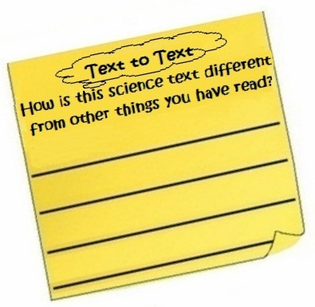You learned that a mixture is created when two or more kinds of matter are physically mixed. There are many kinds of mixtures. Trail mix, a tossed salad, a bag of assorted candy, and breakfast cereal are all examples of mixtures of solids. Air is a mixture of gases.

You learned that because mixtures are physically but not chemically combined, they can be separated back into their parts. Some mixtures can be separated using your hands. Other mixtures can be separated with magnets. Some mixtures can be separated using a filter. Mixtures can also be separated by using nets, strainers, and evaporation.